Accessibility Lessons for Higher Education

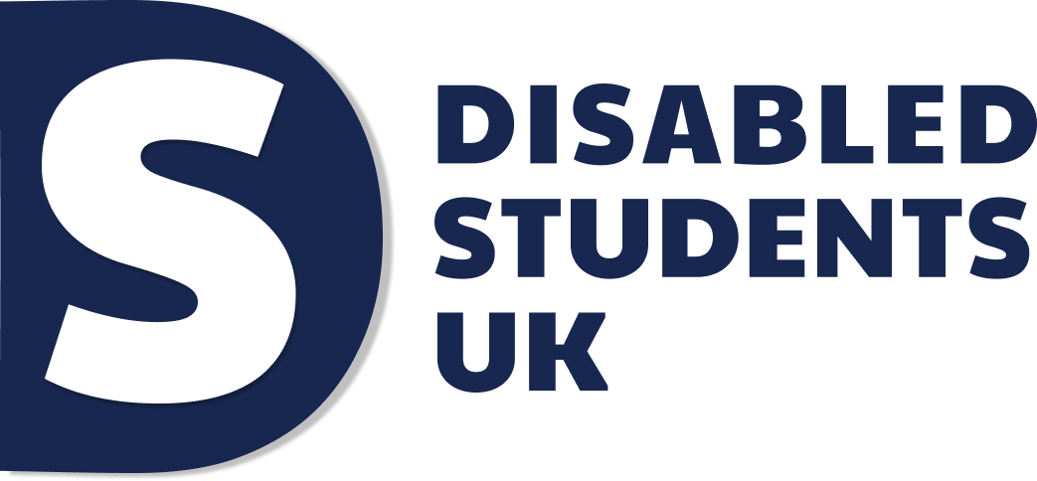

Introduction

Over the last five academic years, the number of UK students with a declared disability has increased by 46% (HESA, 2022a; HESA, 2022b) making up almost 1 in 5 of home students (HESA, 2022b). As we live with the consequences of the COVID-19 pandemic as a mass-disabling event, we expect this trend to accelerate. 2.4% of the UK population is now suffering from long covid (Office for National Statistics, 2022) and many others have experienced a deterioration of their mental health (Office of Health Improvements and Disparities, 2020).

Considering the collective trauma of the pandemic, it is no wonder that many of us are dreaming of “going back to normal”. It is important, however, to re-evaluate what this means. “Normal” as a time and place without social isolation is a mirage. Before the pandemic, many of us lacked equal access to in-person teaching, face to face socials and university campus. For some disabled people, this was made even worse by the pandemic: as society quickly had to create new ways of working, many forgot or deprioritised making them accessible. For others, access improved during the pandemic: as society adapted to the whole population being “housebound”, it inadvertently provided some long sought after “accommodations” such as lecture recordings. Some of us have had better access to services like education during the pandemic than ever before.

What is clear for both these groups is that “going back” to some time where we all had equal access to common spaces without social isolation is not a choice, because such a time never existed. In addition, for a proportion of disabled students, the virus is still life-threatening and will likely continue to be life-threatening for years to come.

The solution of course is not to stay in “pandemic” mode indefinitely. Instead, we must find ways to build accessibility into both our on-campus and online learning – to build on the good that has come out of the pandemic and address the bad. As we move into this new phase of the pandemic response, institutions have a greater opportunity to respond rather than react. Many are searching for avenues of what we might call post-pandemic growth. Luckily, the changes brought on by the pandemic offers many such opportunities.

A year into the pandemic, we conducted a survey with the aim of understanding the lessons that we can draw from how disabled students have experienced the pandemic, and how we can move forward from here. We had 326 respondents from 69 Higher Education Providers (HEPs) across the UK, providing incredibly rich data. In this report we will cover 5 key lessons, inspired by the answers we received to the following question:
“What lessons do you hope that your university learns from the pandemic to become more accessible moving forward?”
The second most common response to this question, which we will come back to at the end of the report, was “listen to disabled students''. We have created this report to enable Higher Education Providers to do just that: hear disabled students’ voices, and act upon their insights in partnership. We want to guide HEPs through the accessibility lessons of the pandemic from a disabled student perspective so that instead of regressing, we can move forward together.

We want to enable the sector to take the first steps toward building something new - a Higher Education sector that is truly accessible.

Introduction 2
Executive summary 7
Lesson 1. Take an anticipatory approach 10
Building on the benefits of online provision 15
Taking an anticipatory approach 17
Lesson 2. Resource staff to be able to provide
accessibility 19
Improving online accessibility 26
Resourcing staff 27
Lesson 3. Build on attitudes 30
Maintaining existing flexible and compassionate policies 34
Building a culture of compassion instead of mistrust 34
Lesson 4. Reduce the administrative burden 37
Reducing the burden 44
Lesson 5. Take responsibility through effective leadership 46
Keeping disabled students in mind requires a
cohesive approach 54
Moving forward is a choice 58
A sixth lesson - Listen to disabled students 60
Access Insight 62
About Disabled Students UK 64
Commissions 65
University breakdown 67
Descriptions and definitions 71
Acronyms 72
Lesson summary 74
Acknowledgements 79
Dedication 79
References 81

Executive summary

69.9% of participants in our survey state that online learning is equally or more accessible compared to in-person learning. At the same time, only 23.1% of participants state that they have received the disability support they require during the pandemic

There are two themes running through this report - one of inequity and another of hope. Some have argued that the changes that have happened during the pandemic have either been a catastrophe or a silver bullet for disabled students. Of course, reality is always more nuanced: In our survey 41.5% of the disabled students who responded state that the accessibility of their course has improved, 29.6% state that the accessibility of their course has worsened while the rest state that it has improved as much as it has worsened. Despite this nuanced picture, institutions will find clear lessons to draw from the data:

Lesson 1. Take an anticipatory approach

To the degree that accessibility has improved during the pandemic it is largely due to a few institution-wide policies, such as online access to lectures and removing time limits from assessments. This shows the enormous influence of a few key universal policies, applied equally to disabled and non-disabled students. Taking an anticipatory approach to find and implement such policies going forward will allow Higher Education providers to increase accessibility more efficiently.

Lesson 2. Resource staff to be able to provide accessibility

The lack of individualised disability support during the pandemic, and the failure to incorporate accessibility into the delivery of institution-wide policies has emphasised the need for staff to have the appropriate resources and training in order to be able to implement accessibility in practice.

Lesson 3. Build on compassionate attitudes

Implementing more flexible and compassionate approaches during the pandemic has provided evidence that such approaches do not have to be in competition with “academic rigour”. The disabled student community wishes to see these copied into a disability-specific context.

Lesson 4. Reduce the administrative burden

The pandemic provides a clear example of the fact that when disabled students have to shoulder a large administrative burden this effectively blocks their access. Reducing the administrative burden is one of the most cost-effective ways to increase accessibility.

Lesson 5. Take responsibility through effective leadership

The pattern of results shows disabled students being forgotten and abled students accommodated. The only way to ensure change is through leadership which enables a coherent whole-institution approach and a culture of responsibility.

Figure 1. Access improved or worsened
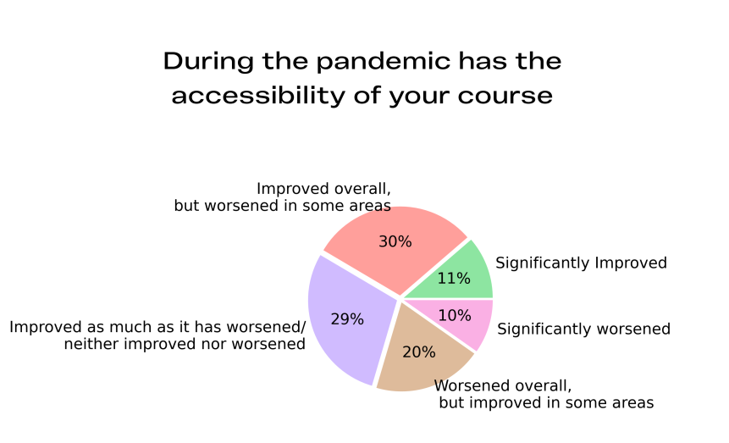

Lesson 1. Take an anticipatory approach
A few institution-wide measures can significantly improve accessibility for disabled students
When we asked disabled students to write about what they hoped their institution would learn from the pandemic, the single most common answer was that they hoped the university would keep some aspect of online/distance learning.

84.5% of our disabled students state that they would benefit from online/distance teaching being an option after the pandemic; 53.3% state that they would benefit a lot.

Figure 2. Continuation of online learning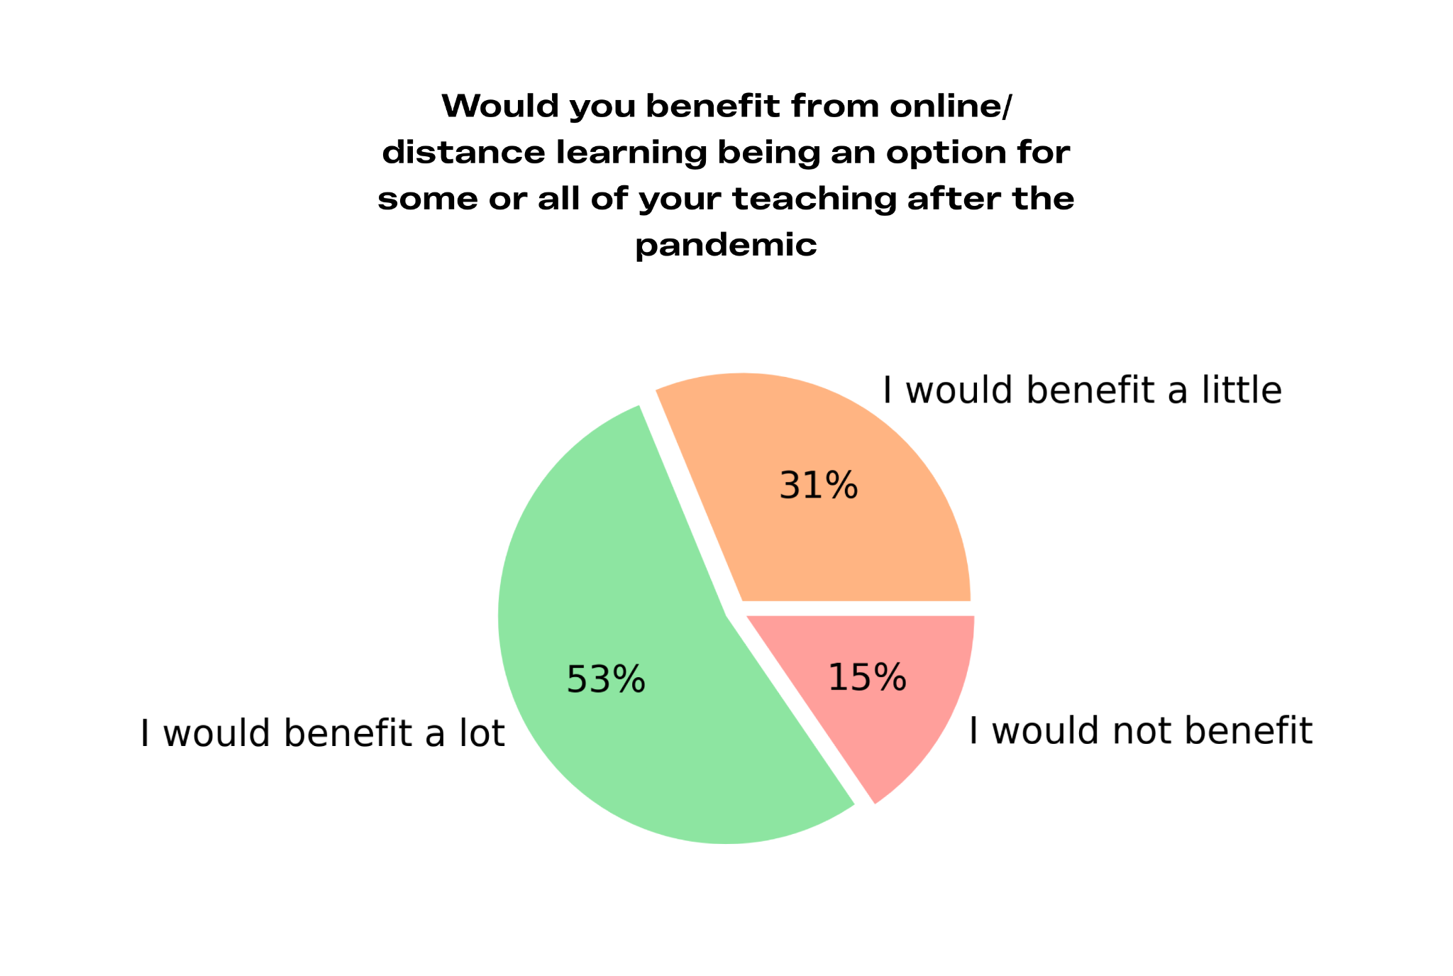
As we know, online learning has the potential to widen participation for a number of groups. Office for Students (OfS) writes in the report “Gravity assist”: “The flexibility offered by digital teaching and learning enables particular student groups to access higher education who might not otherwise be able to” (Office for Students 2021a, p. 91). Online learning has accessibility benefits for existing disabled students as well. It is felt to be more accessible than on-campus learning by 45.2% of our students (compared to 30.1% who found it less accessible). For a type of provision implemented without preparation at a time of crisis, this is a remarkably high proportion. We can speculate that this increase in accessibility is at least partly responsible for the closed gap in degree outcomes between disabled and non-disabled students during the pandemic (Office for Students, 2021b).

Lectures being recorded was perhaps the most often mentioned positive practice by our participants. However, individual students experienced a range of other practices that increased accessibility for them: live-streamed lectures with anonymous interactive options, the option of attending the whole degree at a distance, online seminars or supervisions, ways of communicating with tutors online, alternative assessments, online open houses/drop-in sessions, online appointments and ways of engaging with support services were all mentioned.

To gain further understanding of good accessibility practice we asked students, “Which aspects of online/distance learning have been more accessible to you than on-campus learning?” The benefits mentioned could be divided into the following main categories:

- Physical accessibility: For instance a reduced need to travel. This leads to reduced strain/fatigue and increased attendance.

- Having access to recordings: This enables flexibility in timing of study and reduces risk of missing important information.

- Expanded forms of engaging with teaching: For instance engaging anonymously or in writing during a lecture can reduce anxiety.

- Alternative assessments being offered: This has had a variety of benefits, including not testing rote learning.

- Academic materials being made available: This included materials being made available earlier, via post or in more accessible formats.

Responses to “Which aspects of distance/online learning have been more accessible to you than on-campus learning?”

“I have been able to attend more lectures and even sat my exams in hospital. If university wasn’t online I believe I would have had to drop out by now due to the time I would have missed being unable to attend lectures.“

“Recording of the lectures as I could come back to anything I was unsure of and I could take regular breaks which I need without missing the important parts of the lecture”

Our students report that there has historically been a perception among Higher Education Providers that online provision is somehow inferior, leading them to resist the implementation of such practices for years when disabled students have asked for them. As HEPs have now developed not just their capacity for online provision but an appreciation for its potential, many of our students expressed hope that the status of online learning would be raised, and this type of teaching be prioritised to the same degree as in-person teaching.

Responses to “What lessons do you hope that your university learns from the pandemic to become more accessible moving forward?”

“it is possible to conduct meaningful learning and presentation of educational material online”

“online learning and recording of lectures is respectable and useful. Not an excuse [for] students not to attend in person.”

Building on the benefits of online provision
Listening to the disabled student discourse today we find that the biggest areas of praise and critique concern whether disabled students are being allowed to continue to benefit from online provision. Many disabled students have been able to retain a degree of distance learning despite in-person teaching has become an option again. But others, even those who are at increased risk from the virus, have been made to choose from in-person teaching or leaving their course. A failure to continue providing distance learning options is one of the most common issues disabled students report at this point.

Considering the enormous accessibility gains that have been made, we ask HEPs not to regress to in-person-only provision and leave disabled students behind. In keeping with the recommendation made by the Disabled Students Commission (DSC), we encourage HEPs to conduct an equality impact assessment on their modes of provision going forward and investigate which aspects of online learning can be preserved even as in-person teaching once again becomes the norm.

Specifically, we recommend that HEPs:

- Ensure that no student is forced to choose between putting themselves at risk by going back to in-person attendance or putting their studies on hold.
This means offering online attendance as an option for students who are deemed to be “clinically extremely vulnerable” until such a time that COVID has become less of a risk to them.

- For all courses - keep the aspects of online learning that have most increased accessibility, such as lecture recordings, more easily accessible materials, and a greater flexibility in modes of assessment.

- Expand the number of courses that are possible to attend digitally.
This will not only facilitate the first recommendation above but also allow the university to comply with the guidance from the Equality and Human Rights Commission (EHRC) indicating that any attendance requirements must not apply to students who are unable to attend for disability reasons (Equality and Human Rights Commission, 2014). In addition, it will expand participation more generally such as for those with caring responsibilities and those living with someone who is clinically extremely vulnerable.

Having recommended the continuation of online options, it is important to note that the presence of such options must never be used as an excuse not to implement in-person adjustments. This would lead to segregation of disabled and non-disabled students. For instance, a hard of hearing student who asks for the lecturer to wear a clear mask so that they can lip-read should not be told to instead attend online where there are captions.

Taking an anticipatory approach
Within the accessibility field we often make a distinction between a more anticipatory and more reactive approach. Anticipatory approaches, accessibility policies implemented before an individual student demonstrates a specific need, tend to be more cost-effective, benefit a larger group and be more likely to comply with legal standards.

The success of policies such as obligatory lecture recordings during the pandemic demonstrates the enormous influence simple steps can have on disabled students’ ability to access education. We encourage HE leadership to investigate what proportion of their current accessibility budget is going toward improving accessibility in these cost-effective ways and what steps they are taking to continue to find such practices.

Many HEPs have hired a digital accessibility lead during this time, who is able to take a proactive approach to ensure that the digital environment is accessible. We encourage HEPs to also consider hiring a teaching and learning accessibility lead who would be able to take a proactive approach toward the accessibility of teaching and assessment more widely.

In their 2020 report “Arriving at Thriving” the Higher Education Commission recommends that each Higher Education Provider should have a strategic group (with disabled student representation) undertake a review of disabled students’ access to teaching and learning (recommendation 2). We would argue that the crossroads that we face at this stage of the pandemic is the ideal time for institutions to build a more proactive strategy for disabled students’ access. A number of organisations can help Higher Education Providers create such a strategy:

- Halpin Partnership

- Pete Quinn Consulting

- Alistair McNaught Consultancy and AbilityNet

Lesson 2. Resource staff to be able to provide accessibility
Appropriate staff training and resources is necessary for accessible implementation of teaching and individualised student support.
Another of the key lessons students wanted their university to learn was “one size does not fit all”. It is not enough to adopt a blanket policy such as offering the option of online attendance or providing 24-hours exams. Differing needs must also be considered in the implementation of such policies and there will always be some students who require individualised support.

Despite the overwhelming support for online/distance learning, 62.7% of our participants agreed that they had experienced some accessibility issues with it. We investigated this further by asking students to select which of a number of issues they had experienced.

The most common issues were:

- Too much screen time causing or exacerbating attention issues (64.7%)

- Live sessions causing or exacerbating fatigue (64.2%)

- Difficulties structuring the time (61.8%)

- Lack of (adequate) captions interfering with comprehension (35.6%)

- Unclear assignment structure and information regarding modules (32.7%)

- Lack of accessibility equipment (eg. ergonomic or technological) (24.6%)

Many also added:

- Delayed or inaccessible materials (eg. slides not being accessible through screen readers)

- Difficulties with online communication/social interaction.

- Not being allowed “extra time” in 24-hour exams, resulting in a disadvantage for those with fewer productive hours in a day.

In addition, 23.1% of disabled students did not have a suitable place to learn with a suitable computer, printer and internet access.

Responses to “Please use this space to provide further details on any issues you have experienced with online/distance learning and if it was resolved”

“[I] have repeatedly had to chase up all of my access arrangements and justify them anew because staff thought I no longer had need for them when in fact I needed them more”.

“zero reasonable adjustments [were] provided for online lectures, and as such my lectures were inaccessible to me and I am now having to repeat a year”.

“Some of my assessments will be 24hr exams and these are very unfair as my extra time and rest breaks are not accounted for. The uni says that exams are only supposed to take a few hours so 24hrs automatically accounts for extra time, but my abled peers spend up to 18 hours or more on such assignments”

Figure 3. Received required support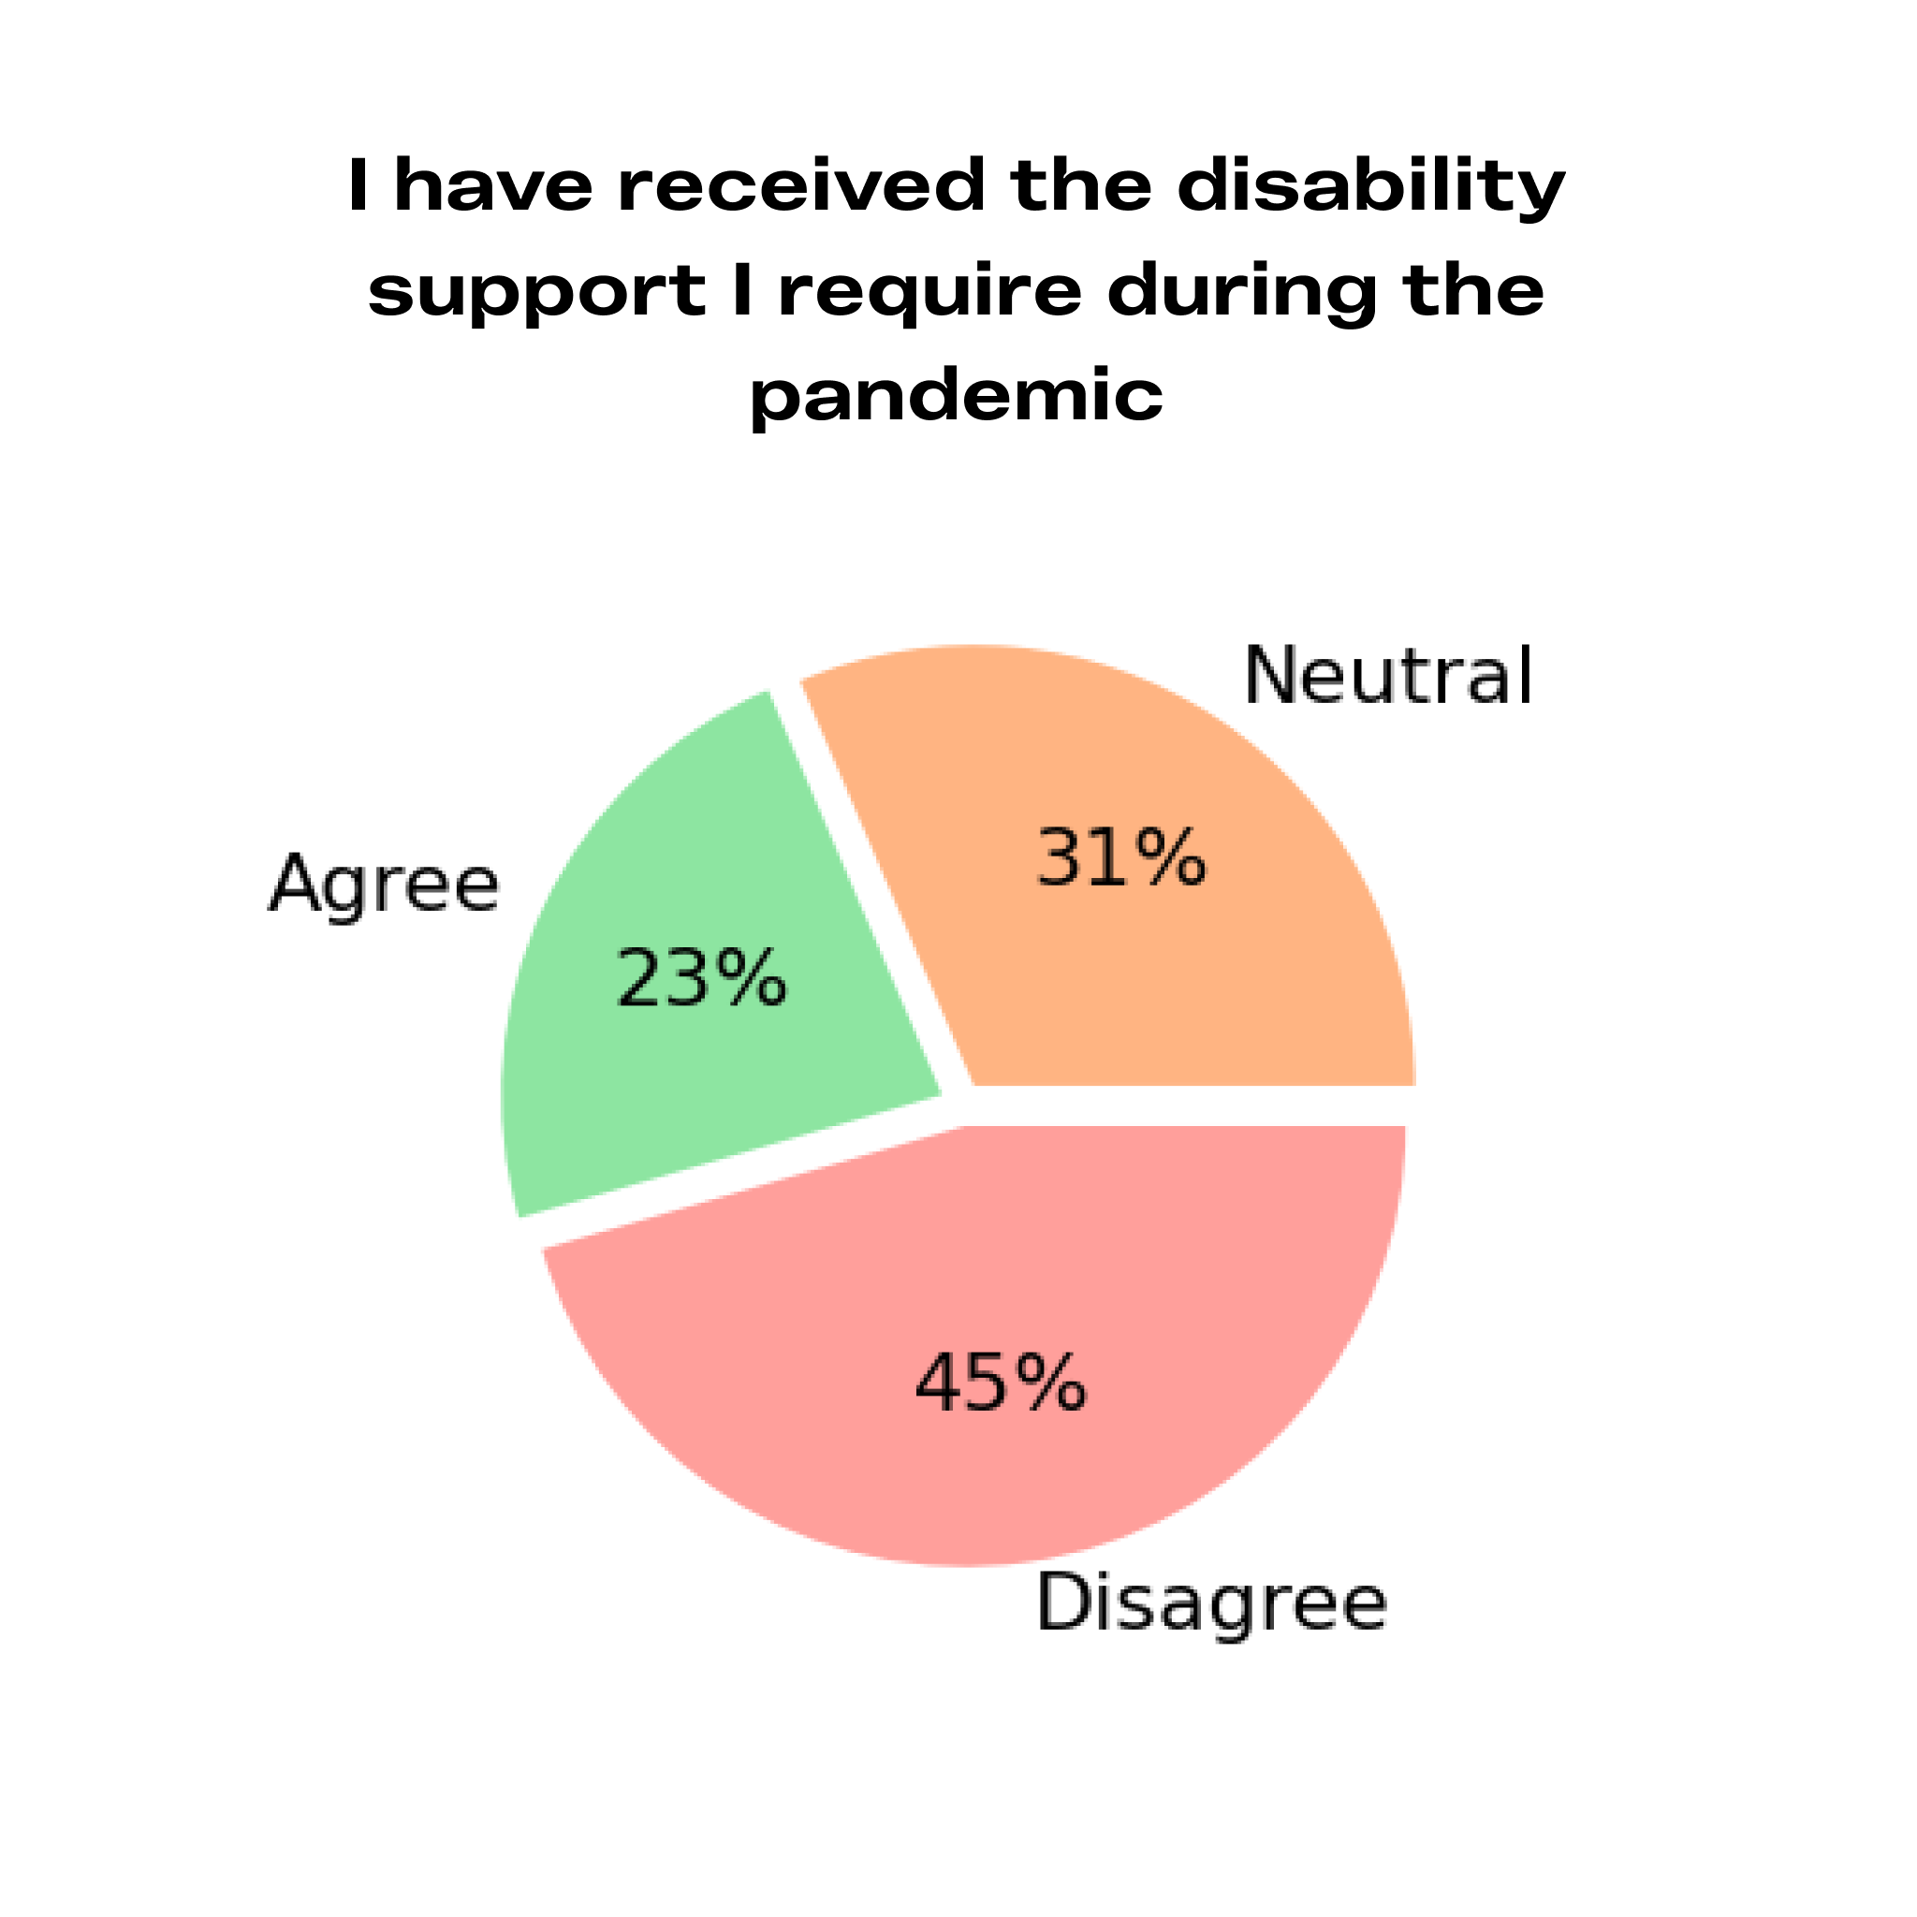
The social model of disability suggests that when the teaching environment changes, disabled students’ access needs change. DSC notes in Three Months to Make a Difference (2020, p.6) that: “Some disabled students will now require reasonable adjustments when they previously have not and some students will now be considered disabled under the Equality Act 2010 when they were previously not”.

In this context it is troubling that many of our participants report Higher Education staff members acting as if individual adjustments are not needed if learning is online and exams are extended over a longer period. This shows a lack of understanding of the social model and treats accessibility as a tick-box exercise.

This attitude is a key reason why only 23.1% of participants agree that they have received the disability support they have required during the pandemic. This number was especially low among shielders (13.6%), international or EU students (9.4%), and those identifying as “Poor/in poverty” (7.1%). That these groups are poorly supported is consistent with previous qualitative research (Higher Education Commission, 2020).

In their latest report “Exploring the impact of Covid-19 on disabled students’ experiences: in-depth qualitative report ” DSC comments that as institutions have focused on supporting the majority of students, disabled students’ needs have sometimes been overlooked (DSC, 2022, p.10). Of those students that have had access issues with online learning, our survey results show that 47.4% had still not seen them addressed a year into the pandemic. Additionally, 34.4% stated that they had been addressed, but it took so long that it affected their studies or wellbeing. Only 26.0% stated that the university had been proactive and efficient in addressing these issues.

Figure 4. Prioritising Accessibility
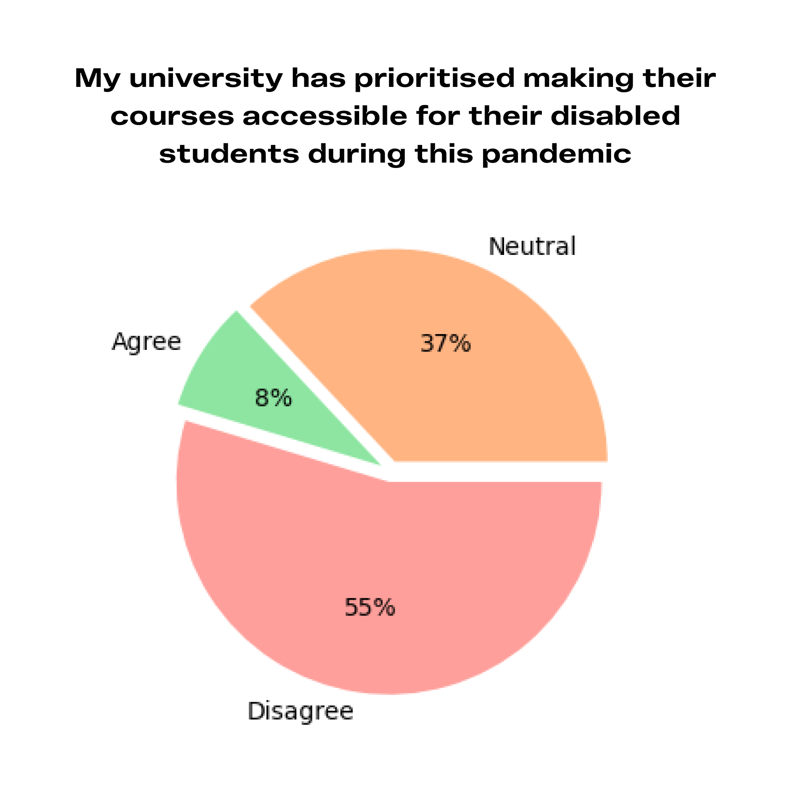
This failure was likely due in large part to a lack of anticipatory consideration for disability, and a lack of resources provided to staff. Only 5.0% of our participants stated that the university proactively consulted disabled students on how to make sure new teaching methods were accessible to them. Instead of providing disability services departments with additional funds, we heard of staff cuts. DSC confirms that students felt that support staff was overloaded (DSC, 2022, p.10).
A study by Ivan Newman presented at the 2021 National Association of Disability Practitioners’ annual conference showed that only 2% of Higher Education Providers conducted equality impact assessments as they moved online and only 15% gave their lecturers advice on how to make their teaching accessible to disabled students.

The failure to meet the anticipatory duty and address raised accessibility issues gave rise to a number of negative consequences for our respondents. Those who stated that they had not received the required support were 69.7% more likely to say that they had considered leaving the university or switching to part-time study. Those who reported that the university either took so long to address online accessibility issues that it affected their studies or wellbeing, or did not address them at all were 46.7% more likely to consider it compared to those who reported that their university had been proactive in addressing issues.

Improving online accessibility
We encourage HEP senior leadership to consider what proportion of their lecturers feel confident that they know how to deliver a lecture in such a way that it is accessible to a variety of disabled students. There has been a lot of pressure on staff during the pandemic; now is the time to take a step back and consider the kind of training they need to be able to deliver qualitative teaching. In “Three Months to Make a Difference” DSC recognises the importance of proactively improving the accessibility of online provision through disability inclusion training for staff: “training will help to ensure there is a consistency in approach across all courses and modules and that people are familiar with functions that will enhance accessibility” (DSC, 2020, p.13).

We ask all Higher Education Providers to:

- Create an institution-wide digital accessibility policy.

- Create or acquire mandatory training for their professional support and academic staff to be able to follow this policy.

There are a number of organisations that can support the creation of a digital accessibility policy and provide staff training within the digital domain:

- AllAble

- Alistair McNaught Consultancy and AbilityNet

Resourcing staff
We encourage senior leadership within Higher Education institutions to investigate what proportion of their disabled students feel they are getting the disability support they need to access their course on equal terms.

Many of the issues highlighted by the pandemic are staff resource issues. We cannot blame individual staff members for failing to recognise and provide the required support when they have not been given the resources and training to do so. Underfunding of disability departments as well as a failure to implement already agreed support, have long been issues in the sector despite a year on year increase in demand, as highlighted in “Arriving at Thriving” (2020). The Higher Education Commission recommends that all HEPs should provide mandatory training for their academic and professional staff that addresses disability inclusion (2020, recommendation 3).

When HEPs create their strategy for disabled students’ access we encourage them to review and fill in gaps in staff resources. In particular we ask HEPs to:

- Provide adequate funding for key staff responsible for accessibility within the institution, including “disability services” as well as the staff responsible for accessibility within other departments such as “digital”, “procurement”, “estates”, “library”, “student wellbeing” and indeed academic departments.

- Ensure that staff responsible for accessibility in the same departments have specialised accessibility training or hire additional qualified staff.

- Create an institution-wide policy for accessible teaching and assessment - beyond digital accessibility.

- Create or acquire mandatory accessibility training for all lecturers and course leaders so that they understand how accessibility is provided within the university and how they themselves can provide teaching/material that is accessible to a wide variety of disabled students.

Audits of current teaching and assessment practices, as well as training, is provided by:

- Diversity & Ability

- International Network of Inclusive Practice

Figure 5. Factors associated with being supported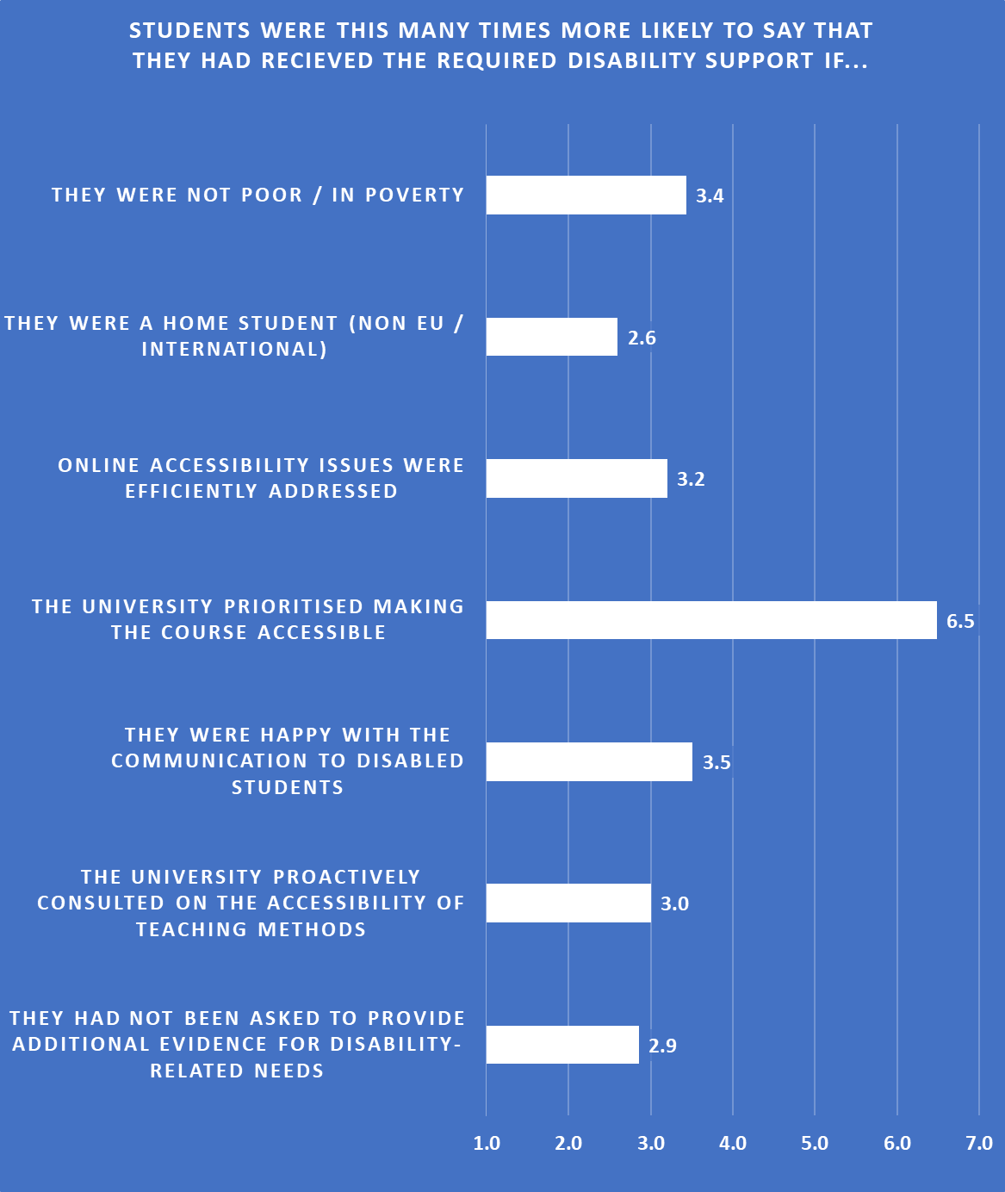

Lesson 3. Build on attitudes
Flexibility and compassion can improve accessibility without lowering standards
The third most mentioned lesson our students wanted their institution to learn from the pandemic was flexibility. Like all institutions, HEPs are often rooted in a particular way of operating. This can lead to alternative approaches such as online attendance being rejected, even when they are more accessible to disabled students.

At the start of the pandemic, HEPs were suddenly forced into greater flexibility – particularly in modes of attendance and ways of demonstrating knowledge. Some HEPs have, for the first time, implemented online provision, open-book exams, uncapped exam resits or adjusted attendance requirements. Practices that were previously rejected out of hand with vague references to “pedagogy” or “academic rigour” have started to be seen as valid, sometimes superior, options. In their report, Gravity Assist, OfS argue that: “Digital assessment is not just consistent with the maintenance of rigour, standards and consistency over time – properly utilised, it can enhance them (2021a, p.10).” In Three Months to Make a Difference the DSC recommends that “students are given a choice of assessments to meet learning outcomes” (2020, p.11).

Our respondents hope that many of these alternatives implemented during the pandemic will remain options, and their status as legitimate forms of gaining and demonstrating knowledge will be raised. In addition, there is a hope that HEPs will become increasingly open to flexibility more generally. HEPs with a more flexible approach have often been better prepared for the many twists and turns of this pandemic. For instance, those HEPs that already provided online alternatives found the move to online-only provision easier when required.

Relatedly, several students report increased acts and policies of compassion. This was sometimes associated with the staff attitude that “we are all struggling in this together” and included an increased awareness that students may be suffering from mental ill-health. Students with mental health problems were more likely to say that they had received the support they required than any other disability group. Many of our students have benefitted from “compassionate policies” ranging from blanket extensions, lowered evidence requirements, increased mental health resources, simplified administrative processes and financial hardship funds.

Disabled students often experience gatekeeping (see lesson 4) and attitudes of suspicion within HEPs, as if by asking for adjustments they are attempting to gain an advantage over other students. In practice, this often keeps them from the adjustments they need to have an equitable opportunity (Wigley, 2016, p.1). However, in implementing the above “compassionate policies” many HEPs have put their fear of academic misconduct to the side, ostensibly because even if a few students were to exploit the system (for instance getting a two week extension on their essay without a medical need) the trade-off is worth it if barriers are removed for those who genuinely need the extra support.

Our students expressed fear that such policies, as they were targeted at non-disabled students having issues due to the pandemic, would be taken away when the pandemic ended, without consideration for the benefits they may provide. Many of the struggles experienced by students at this time, such as isolation or sudden health difficulties, are struggles experienced by disabled students during non-pandemic times and thus these are policies that this group would continue to benefit from. Some students were more optimistic and hoped that not only would these policies continue, but the compassionate approach would carry over into disability specific policies as well.

What lessons do you hope that your university learns from the pandemic to become more accessible moving forward?

“To be more flexible, to provide more options for different methods of learning, one method of learning does not work for everyone.”

“I hope they consider more the specific situations student[s] may face outside of academia. A lot of people have other circumstances which can make education harder and while the university claims to understand this, I don't think they do.”

“that flexibility helps everyone and strict pedagogical arrangements are not always the best way forwards, and that the conditions and parameters of academic learning can bend a lot before they break.”

“I would highly suggest [the policy of not requiring evidence when students ask for extensions or report mitigating circumstances] continuing after lockdowns have finished, as an ability to gather evidence for such things to an extent contradicts the assertion that you are suffering such [circumstances] in the first place.”

Maintaining existing flexible and compassionate policies
We call on HEPs to:

- Continue to offer extensions and accept mitigating circumstances reports without medical evidence for students with a declared disability, in recognition of the inequalities of the medical system and the administrative burden addressed in lesson 4.

- Continue to offer flexible modes of attendance as described in lesson 1.

- When the assessment form is closed-book essay exams, offer an assessment alternative which is not timed, not hand-written and does not rely on rote-learning.

Building a culture of compassion instead of mistrust
We encourage HEPs to investigate what proportion of disabled students within their institution have been treated with suspicion when asking for an adjustment.

Mistrust is not the natural state of things but rather a function of the culture cultivated within an institution. Research funded by the Carnegie Trust UK has investigated kindness in public policy, finding that major challenges facing society require an approach centred on human relationships (Unwin, 2018). During the pandemic we have all seen highly visible examples of kindness, from fundraisers to neighbourhood mutual aid groups. Building a culture of kindness within a Higher Education institution - what Gibson and Cook-Sather (2020) might call “politicised compassion”- takes active work, but ultimately adds great value to the academic and wider student experience.

HEPs have seen through the pandemic that alternative forms of learning and demonstrating knowledge are not necessarily less rigorous and can make a course available to a more diverse pool of students. Our students hope for HEPs to remember these lessons beyond the pandemic context. The Global Disability Innovation Hub writes: “Universities must embed the positive learning, adaptable approach, and accessibility principles from COVID-19 in building back stronger and ensuring the needs of the individual are met” (Global Disability Innovation Hub and Snowdon Trust, 2021, p.4).

When HEPs create a strategy for disabled students’ access (lesson 1), we ask them to take a compassionate and flexible approach. Specifically we recommend that HEPs:

- Reduce evidence requirements specifically for disability related support (further addressed in lesson 3).

- Show compassionate leadership, including providing disabled staff with the same adjustments it is hoped that they will provide students. This will lead to a more representative number of disabled staff members.

- Provide staff with training on the attitudinal aspects of disability inclusion, including training on their legal obligations, what unconscious biases they themselves may have, how they can respond when a student is struggling and how to manage ableism within the subject they teach.

Such training is provided by:

- Disability Rights UK

- AbilityNet

- Diversity and Ability

- Goss Consultancy Ltd

- Pete Quinn Consulting

Lesson 4. Reduce the administrative burden
When disabled students have to carry a large administrative burden this effectively blocks their access
We know from previous studies that the administrative burden placed on disabled students to receive support often blocks support that would have been necessary for the student to have an equitable experience, rather than ensuring that the support ends up in the right hands (Coughlan & Lister, 2018; Department of Education, 2019).

Reading through the accessibility issues reported by students in our survey, it is interesting to note how often a suitable adjustment has been identified and yet the student is not given access to it without going through a taxing and drawn out process of (re)assessment or (re)evidencing.

Responses to “Please use this space to provide further details on any issues you have faced with disability administration during the pandemic”

“I had to contact the disability people about 5 times to get support put in place despite me speaking to them several times and sending them my medical evidence, it only got put in place because my course leader emailed the disability team herself”.

“I can't get the larger screen I have at uni which helps with migraines/visual strain/reading. I've tried to get a screen but they've stated no equipment will be provided. I can't apply via DSA as visual fatigue/migraines weren't included in my assessment report for [specific learning difficulty]”.

“I have been asked for a medical form twice which has cost me £20 each time and this has affected my finances because I lost my job at the beginning of the pandemic. I paid £20 for a sentence and a signature from a doctor that has seen me once”.

“I have been able to apply for mitigating circumstances for any late assignments but if I had my Study Inclusion Plan in place this would not be necessary, and it is stressful having to apply for mitigating circumstances and provide evidence every time for ongoing conditions”

In a sense the pandemic constituted a natural experiment, giving a clear picture of how administration blocks access. Disabled students struggle with administration for a number of reasons:

- Disabled students have less money and energy on average and thus fewer resources to dedicate to administration (Joseph Rowntree Foundation, 2022). This was exacerbated during the pandemic.

- Disability services are often underfunded, and thus struggle when they have high numbers of disabled students going through administrative processes of setting up support at once, for instance during the start of the academic year. During the pandemic 54.5% of our participants state that they have required additional disability support and thus had to go through the process of setting up support again.

- Disabled students with specific conditions or backgrounds often struggle to acquire a diagnosis. Students with long COVID are one such group.

- Even those Disabled Students who have a diagnosis often face difficulties in acquiring evidence due to lack of access to evaluation and long waiting times. This has been exacerbated during the pandemic due to lack of access to doctors, assessment and diagnostic centres.

In this context, HEPs and Disabled Students’ Allowance (DSA) providers have had the opportunity to invest in supportive administrative staff, lower the evidence requirements and/or remove some of the administrative processes they have required disabled students to go through to receive support they needed. Instead our evidence suggests that many HEPs continued the pre-pandemic practice of putting an unreasonable administrative burden on disabled students: 28.3% of our participants report being asked to provide evidence for disability-related needs during the pandemic, despite already having proved to the university that they are disabled. Barriers in the form of evidence requirements, lack of administrative support and consequent delays then blocked students from support.

It can be tempting to blame this block on DSA processes. The DSC found that 27% of disabled students experienced a delay to their provision of DSA (DSC, 2021). However much of the support disabled students receive is now the responsibility of the HEP rather than DSA (Disabled Student Sector Leadership Group, 2017). In addition, when DSA support is unavailable, HEPs have a responsibility to provide equivalent interim support to ensure equal access. Indeed, DSC called upon them to do so in the first summer of the pandemic (DSC, 2020, p.6), and yet a year later DSC found that 76% of students with DSA delays reported no interim support from their HEP (DSC, 2021).

Instead, the support normally provided by HEPs, separate from DSA, was also delayed. Looking at both DSA and HEP based procedures, 62.3% of participants that had gone through a process of acquiring disability support reported that some aspect of the process, from needs assessment to implementation in academic departments, was slowed down or put on hold during the pandemic. That this percentage was higher (73.5%) among international and EU students, who are not eligible for DSA support, provides further evidence that significant administrative barriers have been present within HEPs themselves.

Figure 6. Administration slowed down

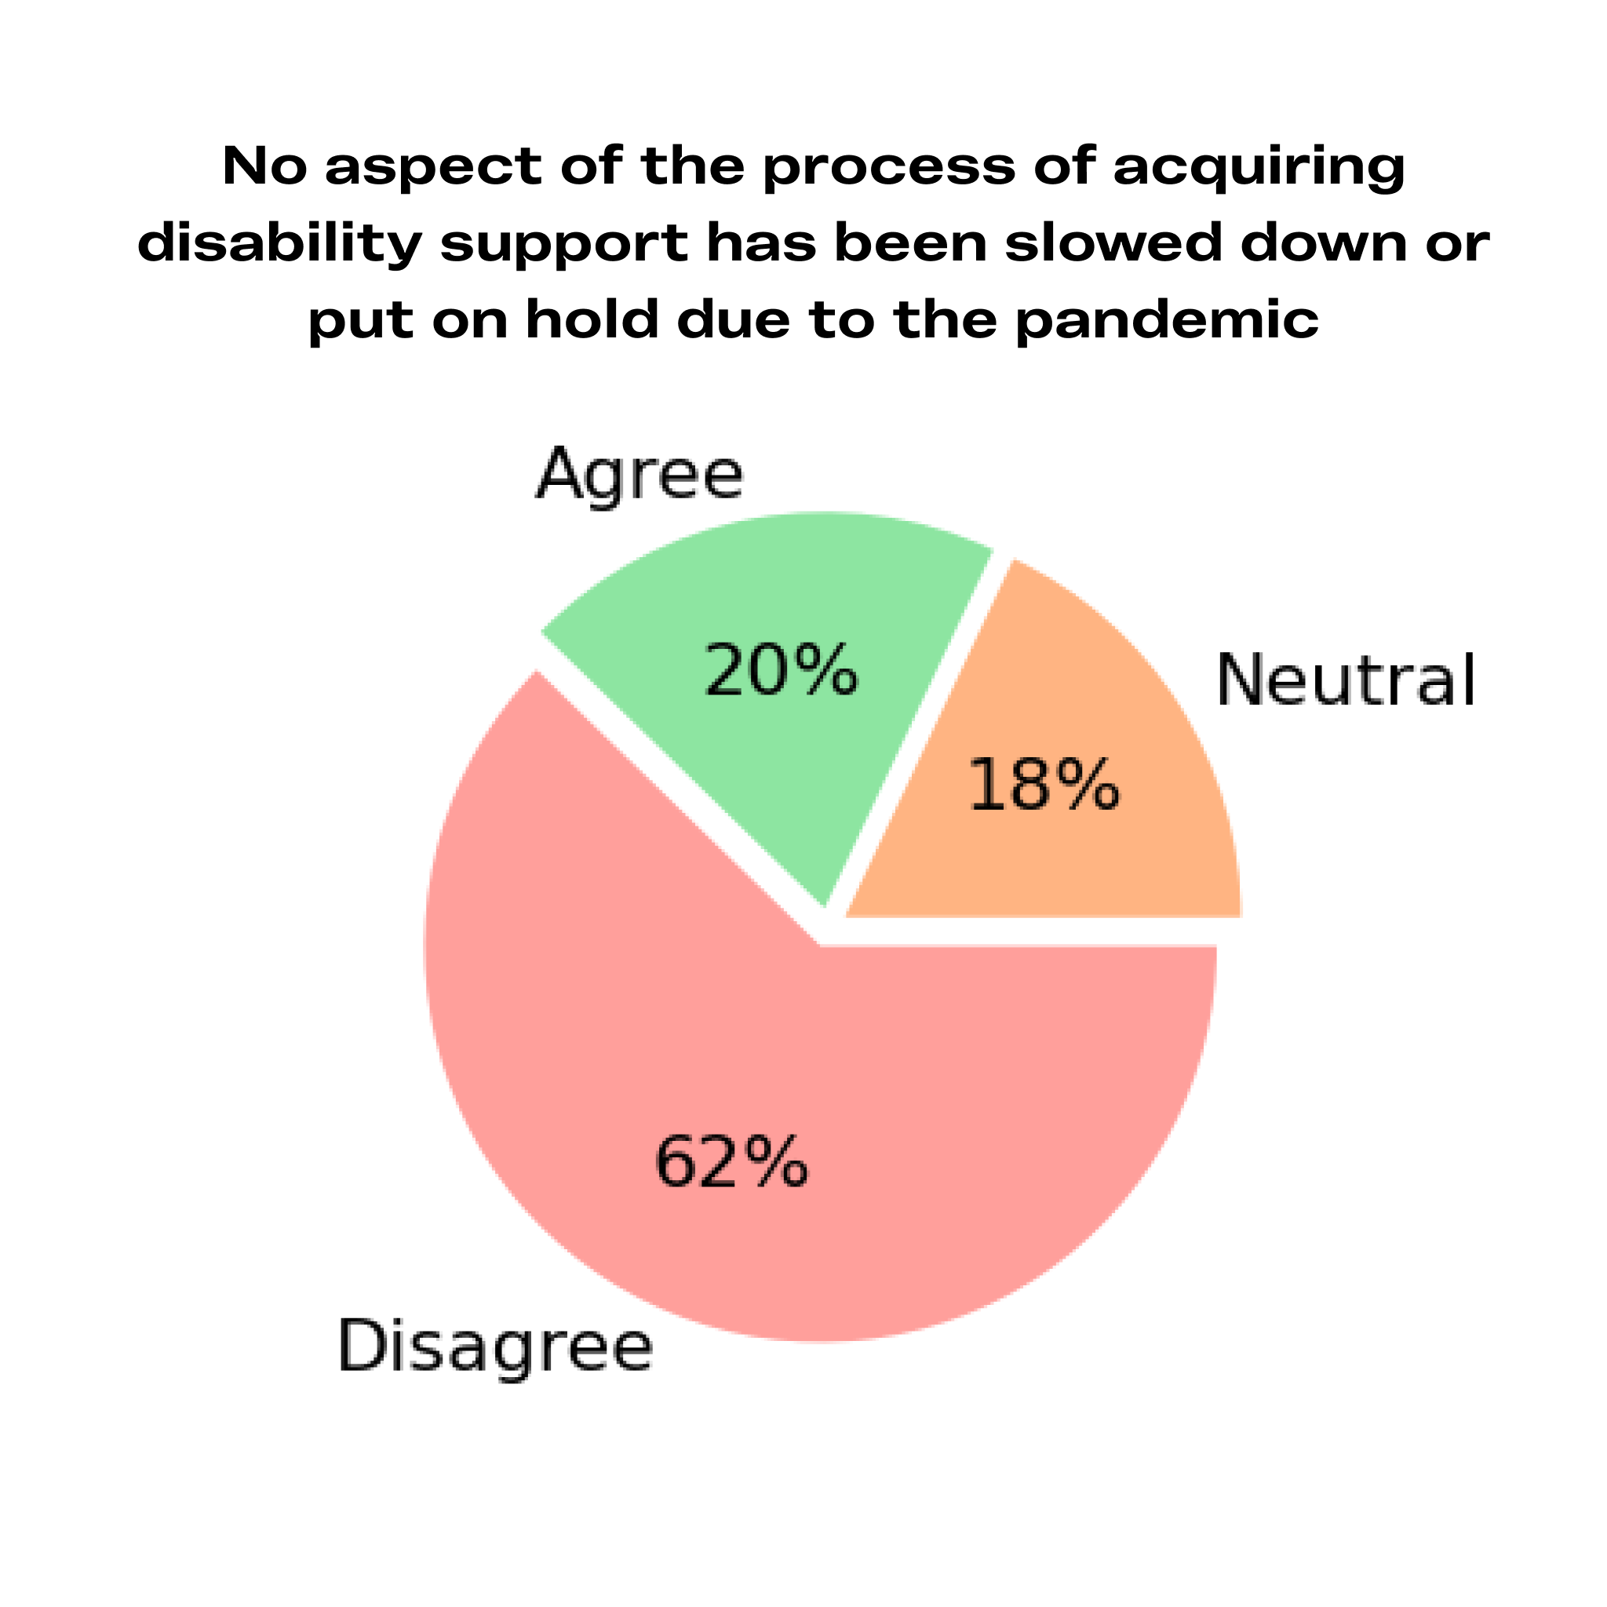

We believe this is key in explaining why only 23.1% of participants agreed that they have received the disability support they required during the pandemic. Disabled students were 2.9 times more likely to say that they had received the support they needed if they had not been asked to provide additional evidence for their disability-related needs. Those who had been asked to provide additional evidence were 32.1% more likely to consider leaving, interrupting their studies or switching to part-time studies.

Responses to “What lessons do you hope that your university learns from the pandemic to become more accessible moving forward?”

“Increased understanding that disabled people know the most about their disability and needs and not constantly asking for proof/questioning when things change seemingly 'out of nowhere'. Accessible adjustments do not give disabled students an 'advantage' over peers.”

“[...] need to require less evidence in relation to extensions and interruptions to study”

“To [...] realise that some of our conditions mean we need [the university] to be proactive”

Reducing the burden
The pandemic provides a clear example of how requiring students to go through extensive administrative procedures in order to receive disability support blocks access in practice. That the system is set up in this way, manifests the mistrust addressed in lesson 3 and is counter to the social model that most HEPs claim to adhere to. In addition it hinders HEPs from abiding by their legal duties: The Equality and Human Rights Commission (2014, p.94) has made it clear that access withheld through delay rather than through outright refusal of support is still access withheld.
In Arriving at Thriving (2020, recommendation 4), the Higher Education Commission finds that the administrative burden has negative consequences for disabled students’ studies and wellbeing. They argue that each Higher Education Provider must monitor and attempt to reduce this burden. Lowering the evidence burden is all the more important now that an increasing proportion of disabled people will be those suffering from long COVID, a condition which is still difficult to have diagnosed.
As HEPs create their strategies for disabled students’ access, we encourage them to investigate the cost of the burden placed on disabled students to prove their need and consider how they are going to reduce this burden. In particular we recommend:
- Making the most commonly provided adjustments, such as provision of lecture recordings, accessible documents and lecture notes, institution-wide policy instead of individually applied adjustments.

- Removing the requirement for students to provide evidence for ongoing or recurring conditions (e.g. not requiring a medical note each time an epileptic student needs an extension due to a seizure).

- Implementing a structure whereby disability staff follow up with academic staff to make sure that adjustments are being implemented, so that the student does not have to repeatedly chase up missing support themselves.

- Set a date in the first term of the academic year by which time 85% of students should have their agreed adjustments in place.

- For specific adjustments, trial allowing students to self-declare whether they need it without requiring evidence. This is standard within other disability support contexts such as the Access to Work scheme (Gov.UK, 2022).

Lesson 5. Take responsibility through effective leadership
The pattern revealed by the pandemic is one of forgetting disabled students even while making adjustments for abled students
Disabled students have been requesting lecture recordings for years. During the pandemic it has suddenly been implemented because abled students need them (lesson 1). At the same time we have seen disability specific adjustments be overlooked, ignored or slowed down (lesson 2). Some HEPs have seen blanket policies of leniency and reduced administration being applied for the benefit of students struggling with the pandemic (lesson 3). In spite of this the administrative burden for disabled students has persisted or increased (lesson 4).

The overarching pattern is that disabled students are de-prioritised.

Responses to questions about issues faced:

“..I was shielding in [university] halls, I had no support, no help and no information. It was only when students came back in September that they put up signs and hand sanitiser. I've felt alone and forgotten.”

“There has never been any communication containing information for disabled students. We are once again left in the dark.“

“I have felt left behind, as if I am a spare part in the University and alienated from my studies, with my ability to participate and study being second place”.

“My university has required less evidence than usual only if it's covid related”

Figure 7. Communication
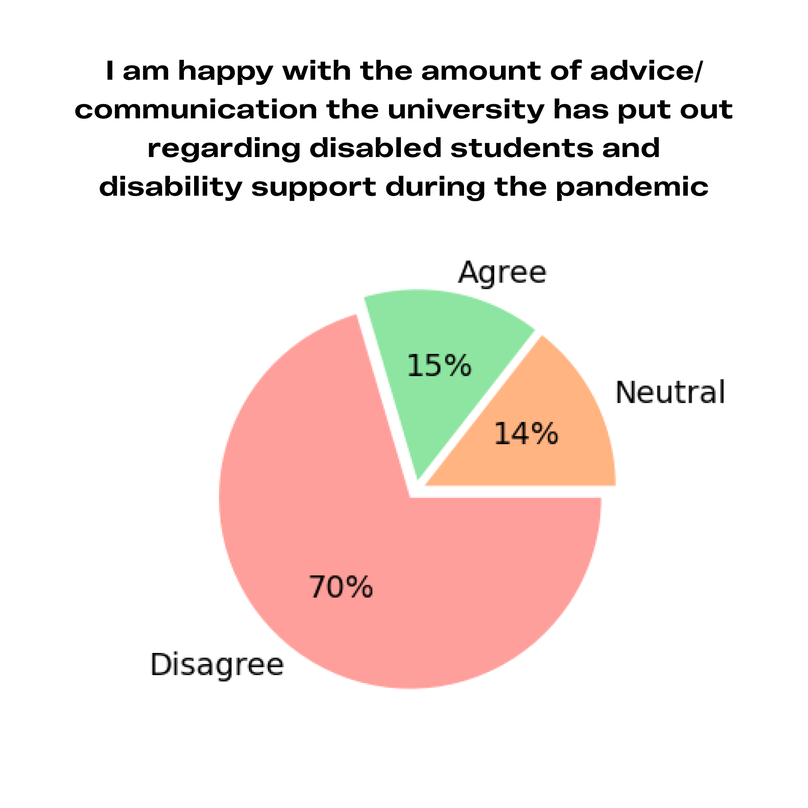
Most of the time the de-prioritisation is subtle. Throughout the data, we see a handful of examples where disabled students have been refused access with COVID as an excuse. Instead we see countless examples of HEPs simply forgetting disabled students:

- Advising those living with the elderly to stay home at the beginning of the pandemic but forgetting that immunocompromised students exist.

- Failing to send out any information about what will happen with disability services under lockdown.

- Failing to inform students how to apply for new needs assessments.

70.5% of our participants are unhappy with the amount of advice/communication their HEP put out regarding disability support for students during the pandemic. This number was even higher for PhD students.

Only 8.4% of our participants felt that their institution has prioritised making their courses accessible for disabled students during the pandemic. We saw in lesson 2 that many HEPs had failed to consider accessibility in their online provision. Similarly, many HEPs did not consider accessibility in implementing on-campus safety measures. 41% of participants who had experienced on-campus education during this time stated that new access issues have arisen on campus - most often due to mask use and changes to the physical environment. Of these participants, 53.1% stated this had still not been addressed a year into the pandemic 36.7% stated that it had been, but it took so long that it affected their studies or wellbeing. Only 18.4% stated that the university was proactive and efficient in dealing with the issue.

Shielding students (18.4% of our sample) have been one of the most vulnerable disabled groups throughout this period, and sadly also one of the groups that has received the worst support from their education institution. Shielders are less likely to say that they have received enough advice/communication compared to non-shielders (8.3% vs 16.5%), less likely to say that they have received the disability support they need (13.6% vs 25.1%) and more likely to say that they had considered leaving, interrupting or switching to part-time studies (75.0% vs 52.9%).

Figure 8. Considering leaving
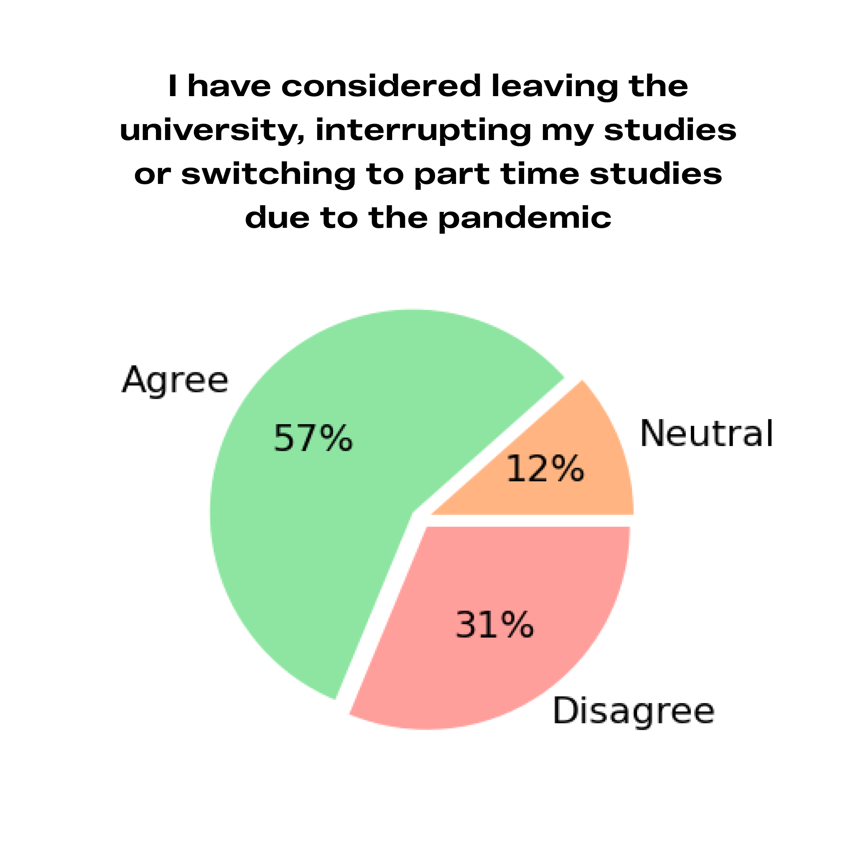
Overall, 57.2% of disabled students in our sample have considered leaving their university, interrupting their studies or switching to part-time studies due to the pandemic. The Higher Education Policy Institute 2021 Student Academic Experience survey found that 43% of disabled students had considered leaving their university – 1.65 times more than non-disabled students (Neves & Hewitt, 2021). If this high consideration rate had been true for the student group as a whole, we would consider it a tragedy and talk about the enormous detrimental impact of the pandemic. In the case of disabled students the high rate is likely a continuation of a historic trend. Already in 2019, 55% of Randstad support recipients reported that they had considered leaving their course (Randstad, 2020). It is important that we do not consider it less of a tragedy simply because it is normalised.

It is easy to think that disabled students are more likely to leave due to their impairments, but this is not borne out in our data. As we see in Figure 9 the factors that are most associated with a disabled student considering leaving are factors such as not being given enough support and information and their HEP not prioritising accessibility or consulting disabled students - not what disability they have.

Responses to “What lessons do you hope that your university learns from the pandemic to become more accessible moving forward?”

“To actually keep disabled students in mind when coming up with plans/strategies. There were several times when I had to lobby management at my University to change policies to make them more accessible, or to ensure disabled students were considered in the plans. Disabled students felt like an afterthought”.

“there shouldn’t have had to be a pandemic to make things accessible“

“Disabled students' needs are a priority, not an afterthought.”

Keeping disabled students in mind requires a cohesive approach

Response to “What has your university been doing well concerning the accessibility of distance/online learning?”

“Any accommodations I've received are basically personal choices made by individual members of staff, not the university at large”

Proactively considering accessibility, training staff, addressing attitudes and reducing the administrative burden are all important solutions to the issues we have highlighted throughout this report. However, where there is an underlying pattern of forgetting disabled students, it is essential that there is a deeper review of the structures of responsibility within the institution. In particular, recent work in this area has highlighted the importance of leadership and accountability in maintaining strategic aims and focus on accessibility (Higher Education Commission, 2020, recommendation 1).

Our results show great variability in policies and approaches within an individual institution. This is consistent with the finding of previous reports such as Arriving at Thriving (Higher Education Commission, 2020) that, on matters of accessibility, individual departments, and within them individual staff members, tend to act on their own, without clear guidance, support or accountability.

This has especially negative consequences considering that the task of providing an accessible experience for a single disabled student is often divided between a large number of departments, such as estates, digital, academic and student support. It is also a highly inefficient system. Even when those with expertise within one area of accessibility find a good accessibility solution, they often do not have the authority to follow up in other departments to ensure that it is implemented. With no one taking ultimate responsibility for their access, students can be bounced from person to person when they call attention to an access barrier (Disabled Students Network UCL, 2020; Gibson and Cook-Sather 2020). Within such a system it is no wonder that disabled students are forgotten.

The Chairs of the Higher Education Commission write “We believe that in order to create the change necessary within individual institutions and across the higher education sector, a senior leader at every institution must take on responsibility and accountability for the experiences of disabled students, making this a personal and institutional priority. Without this, practical support for disabled students can vary widely within an institution, causing unacceptable barriers for students”(Higher Education Commission, 2020, p.4).

We agree that leadership is key and add that staff across a variety of departments must be united under this leadership. Only when interdepartmental communication and structures of accountability are in place, will the institution be able to truly take responsibility for disabled students' access. The same issue was identified in the latest Snowdon Trust and Global Disability Innovation Hub (GDI Hub) Disabled Students’ Survey (2021) which highlighted the importance of streamlined approaches and recommended that universities use a single point of contact for each disabled student: “Improved communications between students, university departments and funding streams are desperately required” (Global Disability Innovation Hub (GDI Hub) and Snowdon Trust, 2021, p.3)

As part of their strategy for disabled students’ access, we encourage HEPs to create a group which brings together the staff members responsible for accessibility within different departments and allows them to move strategically and cohesively toward the accessibility goals of the institution. Consultancy on accessibility leadership structures can be provided by:

- Alistair McNaught Consultancy and AbilityNet

- Halpin Partnership

- Pete Quinn consulting
Figure 9. Factors associated with considering leaving or switching to part time studies.
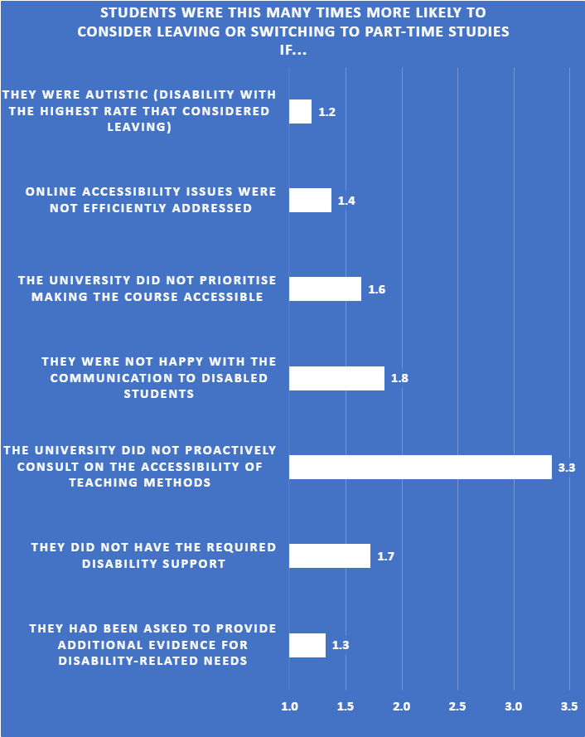

Moving forward is a choice
Seeing the pattern of disabled students being forgotten means seeing the risk that when the main beneficiaries of practices like lecture recordings are once again disabled students, these new forms of accessibility will disappear and the progress that has been made will be lost.

This has already happened in some institutions - disabled students who were better able to access teaching during the lockdowns are once again being shut out as some HEPs have stopped more accessible provision.

However, seeing the pattern also gives us tools to change it. In the post-lockdown world, no university can argue that they cannot provide online resources, cannot lower administrative barriers or cannot apply compassionate policies. In this sense, going back is not a choice for Higher Education Providers either. Luckily, as we have attempted to show throughout this report, the pandemic has equipped HEPs with experience and capacity which opens many routes forward:

- Higher Education Providers have become far more equipped to deliver online and distance content in the last two years;

- Because this coincided with the new digital accessibility regulations, some HEPs have been challenged to think about accessibility in the delivery of teaching in a more systematic way for the first time;

- A number of resources have developed which HEPs can use to understand barriers and enablers for disabled students;

- Many staff and students have experienced a sense of community and compassion during the pandemic that they can invoke in advocating for the importance of inclusion going forward;

- Awareness around mental health and hidden disabilities has increased;

- It has been shown that academic rigour does not crumble when we allow flexibility in our approach to teaching and assessment.

HEPs can use the challenges they have faced in the last two years, and the strengths that they have developed through this process, to adopt a new approach to accessibility.

By taking on the lessons of the pandemic and moving forward with a responsible, proactive, and compassionate approach, they have the opportunity to make it possible for disabled students to access education on equal terms for the first time.

A sixth lesson - Listen to disabled students

Response to “What lessons do you hope that your university learns from the pandemic to become more accessible moving forward?”

“Start with having conversations with students with disabilities, listening to us, understanding what we really need and acknowledging and acting upon those needs [...] not ignoring our complaints but, on the contrary, learning and improving from them, using surveys designed by students with disabilities to know how they are doing every six months, and having training every year with experts by experience.”

The second most common response to the question of what universities should learn moving forward was to listen to disabled students. The importance of consulting with disabled students has been highlighted by the Higher Education Commission (2020, recommendation 2 and 11) and Office for Students (2021a , p.25). Although it is a small group, those students who stated that their university had proactively consulted with disabled students were 3.3 times less likely to consider leaving.

Figure 10. Proactive consultation
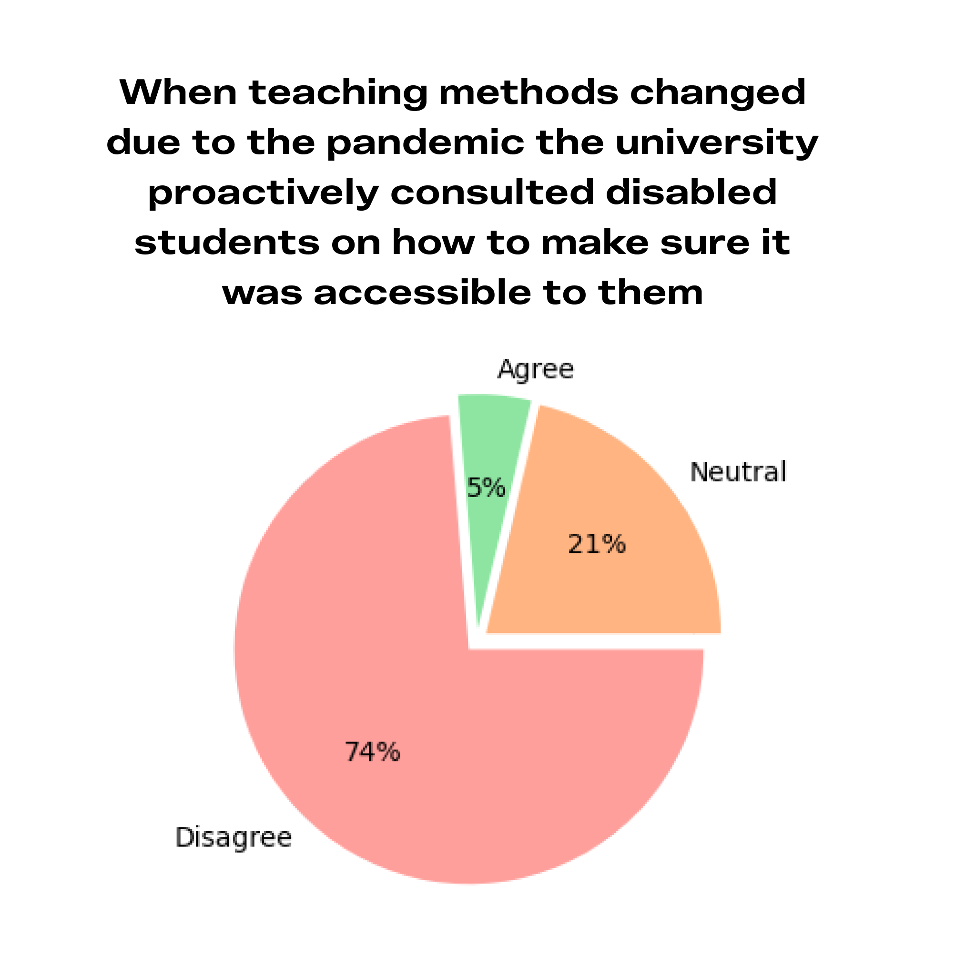
This report has been an attempt to facilitate the start of a journey toward greater understanding of the disabled student experience and toward an inclusive provision of education, but it is only a first step. As HEPs create their strategies for disabled students’ access, we encourage them to consider how they can utilise disabled students’ insight to improve accessibility in the most effective way. In particular we recommend that they:

- Find ways of utilising the insight of local disabled student representation if it exists, and consider how they can support the development of such representation if it does not.

- Conduct a yearly survey into disabled students’ experiences at the institution.

Access Insight
Those institutions that wish to improve accessibility using an evidence and lived experience driven approach should consider joining the Access Insight Network. This is a project designed by Disabled Students UK to allow universities to benefit from the insight of disabled students. The Access Insight project will evaluate disabled students' experiences within the institution to provide valuable information about areas of strength and challenges as well as which accessibility policies are associated with successful outcomes. The results will be updated yearly, tracking progress across the years. Higher Education Providers that sign up to our Access Insight Network make a financial contribution to the project and in return receive:

- A yearly tailored report with recommendations for how the institution can move forward based on disabled students’ experiences at the institution.

- A monthly Access Insight brief with informative videos from lived experience experts.

- 6 hours of DSUK consulting tailored to the HEPs key improvement goals.

DSUK is currently looking for pioneering institutions to take part in the pilot. Please contact us at
accessinsight@disabledstudents.co.uk with any enquiries.

About Disabled Students UK

Our Mission: To achieve a truly accessible Higher Education experience, ensuring disabled people equal access to education and the societal and self-development opportunities associated with this.

Disabled Students UK has quickly become the largest disabled student-led organisation in the UK. We are made up of almost 500 current and former disabled students from 60 different Higher Education Providers. Due to this and our evidence-based approach, we have been repeatedly approached by decision-makers for consultation. We use disabled-led expertise to increase accessibility in Higher Education. We achieve this through empowering disabled students, spreading disabled students’ insights into accessibility and informing policy.

From rather humble beginnings, through the dedication, commitment and the collaborative practices of our community, we are already having an impact on the sector. A few of our key achievements over the last two years have included:

- Our report on Impact of the Pandemic on Disabled Students and Recommended Measures (Disabled Students UK, 2020) being mentioned in Parliament;

- Leading training for Student Union Staff on Tackling Disability Issues and supporting Disabled Students;

- Being recognised in the Disability Power 100 list as one of the most influential disabled-led organisations in Britain (The Shaw Trust, 2021).

Read more about us and our work here:
www.disabledstudents.co.uk
Find us across the web:
https://linktr.ee/DisabledStudentsUK
Email us on:
contact@disabledstudents.co.uk

Commissions
Disabled Students UK has experience working with a variety of stakeholders and offers services which allows Higher Education Providers to benefit from the insight of disabled students in a way that is tailored to the institution. For instance, we can be commissioned to:

- Create a report on the challenges faced by disabled students who are from a low socio-economic background.

- Consult on how you can avoid accessibility issues while maintaining safety mechanisms on campus.

- Help you build a collaborative relationship between staff and disabled students at your own institution.

- Run a targeted focus group session to inform monitoring evaluation and learning about new accessibility policies within your institution.

- Create a report with tailored recommendations based on the survey responses of students from your specific institution (see University Breakdown for some summary statistics).

University breakdown
The tables below cover some key statistics for institutions that had more than ten respondents each. We urge caution in interpreting these results due to the small sample size.

 | University of Exeter (n=27) | Open University  (n=23) | Swansea University (n=20)
Received required disability support | 23.10% | 27.30% | 20.00%
Considered leaving, interrupting studies or switching to part time studies | 42.30% | 57.10% | 80.00%
Not proactively consulted on accessibility of teaching | 88.50% | 38.10% | 90.00%
Accessibility not a university priority | 69.20% | 31.80% | 55.00%
Asked to provide additional evidence | 11.10% | 56.50% | 35.00%

 | Cambridge University (n=18) | Keele University  (n=15) | Oxford University  (n=13)
Received required disability support | 23.50% | 6.70% | 33.30%
Considered leaving, interrupting studies or switching to part time studies | 77.80% | 60.00% | 66.70%
Not proactively consulted on accessibility of teaching | 88.20% | 86.70% | 61.50%
Accessibility not a university priority | 72.20% | 66.70% | 53.90%
Asked to provide additional evidence | 38.90% | 60.00% | 38.50%

 | University College London (n=12) | University of Plymouth (n=11) | University of East Anglia (n=11)
Received required disability support | 41.70% | 27.30% | 9.10%
Considered leaving, interrupting studies or switching to part time studies | 58.30% | 63.60% | 54.60%
Not proactively consulted on accessibility of teaching | 90.90% | 72.70% | 63.60%
Accessibility not a university priority | 66.70% | 45.50% | 72.70%
Asked to provide additional evidence | 58.30% | 9.10% | 27.30%

Positive examples

- More than half of surveyed students at the Open University reported that disabled students had been proactively consulted to make sure teaching was accessible to them. More than half felt accessibility was a priority for the university.

- Results indicate that University of Exeter has generally not asked their disabled students to provide further evidence in order to get support. Exeter is also the only university where fewer than half of surveyed students have considered leaving.

- A majority of surveyed students at University of Plymouth felt that accessibility was a priority for the university. Results also indicate that the university has generally not asked their disabled students to provide further evidence in order to receive support.

Descriptions and definitions
Disabled - The UK disability movement prefers identity-first language (“a disabled person”, not “a person with a disability”) due to our adherence to the social model. Different individuals will have different preferences for how they describe themselves, and this should be respected.

The social model of disability - A model that describes disability as a product of an interaction between our impairment/difference and the society that we live in. According to this model we are disabled by our environment.

Abled - We use the words “abled” and “non-disabled”
interchangeably.

Study Inclusion Plan - The list of adjustments drawn up for disabled students when they first meet with the institutions’ disability services. Each institution has their own name for this: Study Inclusion Plan, Summary of Reasonable Adjustments, Inclusive Learning Plan etc.

Administrative burden - The financial, cognitive, energy and time cost associated with the administrative process that a student has to go through in order to receive the required support. This often includes searching for information, gathering evidence, describing difficulties, attending meetings and “chasing up” support.

Adjustment - “Accommodation” and “adjustment” are used interchangeably in this report to describe the changes made to a practice to avoid putting disabled students at a significant disadvantage compared to abled peers.

Acronyms
APPGs - All-Party Parliamentary Groups

ANMHP - Association of Non-Medical Help Providers

DSA - Disabled Students’ Allowance
DSA is funding provided by the Department of Education to support disabled students in further or higher education. The funding helps to cover the additional costs that arise due to requiring equipment or support to access teaching and learning. DSA is offered to those Home students who can evidence their disability.

DSC - Disabled Students’ Commission
The DSC is an independent and strategic group that was established by the Universities Minister to advise, inform and influence HEPs to improve support for disabled students.

HEP - Higher Education Provider
As per the HESA (Higher Education Statistics Agency) definition, a HEP is any institution that provides higher education. It includes publicly funded universities and other higher education institutions. For example some Further Education (FE) colleges provide courses at a Higher Education (HE) level.

NMH - Non-medical help
This is a form of support for disabled students that is not medical. It can take the form of a note taker for class, study support skills and mentorship.

OfS - Office for Students
The regulatory body for Higher Education for England.

EHRC - Equality and Human Rights Commission
A non-departmental public body tasked with upholding human rights in England and Wales

Lesson summary

 | Lesson | COVID phenomenon | Action points
1 | Implement an anticipatory approach | A few universal measures have disproportionately increased accessibility | - Ensure continued access for the clinically extremely vulnerable.  - Ensure continuation of online learning advantages, including lecture recordings.  - Extend the number of courses that can be attended entirely digitally.  - Create a disability strategy which improves balance between anticipatory and reactionary measures.  - Hire an accessible teaching lead.
2 | Provide staff with necessary resources and training | Lack of proactivity and resources have led to a failure to make online provision accessible and provide individual adjustments | - Provide lecturers and course creators with institution wide guidelines and training for digital and in-person accessibility.  - Provide accessibility staff with funding and specialised training.
3 | Build on compassionate attitudes | Flexible and compassionate approaches have increased accessibility without lowering academic standards | - Continue not demanding evidence for extensions and mitigating circumstances.  - Offer alternatives to timed exams.  - Provide staff training on attitudinal aspects of disability inclusion.  - Lower evidence requirement for disability support.
4 | Reduce the administrative burden | The administrative burden has blocked disabled student support | - Make most commonly provided individual adjustments institution-wide policy.  - Remove the requirement for students to provide repeated evidence for ongoing or recurring conditions.  - Implement a structure whereby disability staff follow up on adjustment implementation.  - Set a date in the first term of the academic year by which time 85% of students should have their agreed adjustments in place.  - Trial allowing students to self-declare whether they need an adjustment.
5 | Take responsibility through effective leadership | Lack of leadership on accessibility has led disabled students to be forgotten and de-prioritised | - Create an interdepartmental accessibility team answering to a senior staff member responsible for disabled students’ experience across the university.
(6) | Listen to disabled students | Disabled students have not been proactively consulted, leading to inefficiency in the accessibility response to the pandemic. | - Measure accessibility through a yearly disabled student survey.  - Involve local disabled student representation in accessibility work.

Acknowledgements
This report was written by the Disabled Students UK Research Team: Mette Westander, Patricia Castellano Verdecia, Felicity McKee, Stephanie Worton and Jo Copson.

We give thanks to our disabled student activist community and the countless allies who gave feedback along the way. In particular we thank Stacey Lyons and Aminder Virdee for contributing to the accessibility and intersectionality of the survey and Promit Anwar for leading on the quantitative data analysis.

We also wish to acknowledge those who keep DSUK running: Mark Glasgow, Amelia McLoughlan, Mette Westander and Anonymous.

Dedication
Filling in surveys can be a form of activism; a way of caring for one's community and those that will come after. This work is the result of hundreds of disabled student participants selflessly giving of their time so that Higher Education can improve. We are incredibly grateful that so many chose to contribute with their insight. This report is dedicated to them.

References

Coughlan, T., & Lister, K. (2018). The accessibility of administrative processes: Assessing the impacts on students in higher education. https://doi.org/10.1145/3192714.3192820
Department of Education. (2019). Evaluation of disabled students’ allowances. https://www.gov.uk/government/publications/evaluation-of-disabled-students-allowances-dsas
Disabled Student Sector Leadership Group. (2017). Inclusive Teaching and Learning in Higher Education as a route to Excellence. https://assets.publishing.service.gov.uk/government/uploads/system/uploads/attachment_data/file/587221/Inclusive_Teaching_and_Learning_in_Higher_Education_as_a_route_to-excellence.pdf
Disabled Students Commission. (2020). Three Months To Make A Difference. https://www.advance-he.ac.uk/news-and-views/three-months-make-difference
Disabled Students Commission. (2021). Exploring the impact of Covid-19 on disabled students’ experiences. https://s3.eu-west-2.amazonaws.com/assets.creode.advancehe-document-manager/documents/advance-he/DSC_Impact of Covid19_student experience_1628763062.pdf
Disabled Students Commission. (2022). Exploring the impact of Covid-19 on disabled students’ experiences: in-depth qualitative report . https://www.advance-he.ac.uk/knowledge-hub/exploring-impact-covid-19-disabled-students-experiences-depth-qualitative-report
Disabled Students Network UCL. (2020). Disability Discrimination Faced by UCL Students & Recommended Measures. https://studentsunionucl.org/articles/disability-discrimination-faced-by-ucl-students-and-recommended-measures
Disabled Students UK. (2020). Impact of the Pandemic on Disabled Students and Recommended Measures. https://disabledstudents.co.uk/DSUK_Report_Update.pdf
Equality and Human Rights Commission. (2014, April 1). Equality Act 2010 Technical Guidance on Further and Higher Education . Equality and Human Rights Commission. https://www.equalityhumanrights.com/en/publication-download/equality-act-2010-technical-guidance-further-and-higher-education
Gibson, S., & Cook-Sather, A. (2020). Politicised compassion and pedagogical partnership: A discourse and practice for social justice in the inclusive academy. International Journal for Students as Partners, 4(1), 16–33. https://doi.org/10.15173/IJSAP.V4I1.3996
Global Disability Innovation Hub (GDI Hub), & Snowdon Trust. (2021). Disabled Students Survey. https://www.snowdontrust.org/disabled-students-survey
Gov.UK. (n.d.). Access to Work: get support if you have a disability or health condition: Eligibility . Gov.UK. Retrieved March 6, 2022, from https://www.gov.uk/access-to-work/eligibility
HESA. (2022a, January 25). Higher Education Student Statistics: UK, 2020/21 . HESA. https://www.hesa.ac.uk/news/25-01-2022/sb262-higher-education-student-statistics
HESA. (2022b, February 10). Who’s studying in HE? HESA. https://www.hesa.ac.uk/data-and-analysis/students/whos-in-he
Higher Education Commission. (2020). Arriving At Thriving: Learning from disabled students to ensure access for all. https://www.policyconnect.org.uk/research/arriving-thriving-learning-disabled-students-ensure-access-all
Jackson, A. (2021). The expectation gap II - students’ hopes for learning and teaching in the next normal . WonkHE. https://wonkhe.com/blogs/the-expectation-gap-ii-students-hopes-for-learning-and-teaching-in-the-next-normal/
Joseph Rowntree Foundation. (2022). UK Poverty 2022: The essential guide to understanding poverty in the UK . https://www.jrf.org.uk/report/uk-poverty-2022
Neves, J., & Hewitt, R. (2021). The Student Academic Experience Survey 2021. https://www.hepi.ac.uk/2021/06/24/the-student-academic-experience-survey-2021/
Newman, I. (2021, June 21). Covid Lockdown March-July 2020 English HE Providers’ Move to 100% online teaching - The needs of Disabled Students. National Association of Disability Practitioners. https://www.youtube.com/watch?v=Ya591yr4ip8
Office for Health Improvement and Disparities. (2020, September 8). COVID-19 mental health and wellbeing surveillance: report. Office for Health Improvement and Disparities. https://www.gov.uk/government/publications/covid-19-mental-health-and-wellbeing-surveillance-report
Office for National Statistics. (2022, March 3). Prevalence of ongoing symptoms following coronavirus (COVID-19) infection in the UK . Office for National Statistics. https://www.ons.gov.uk/peoplepopulationandcommunity/healthandsocialcare/conditionsanddiseases/bulletins/prevalenceofongoingsymptomsfollowingcoronaviruscovid19infectionintheuk/3march2022
Office for Students. (2021a). Gravity assist: Propelling higher education towards a brighter future-Digital teaching and learning review. https://www.officeforstudents.org.uk/publications/gravity-assist-propelling-higher-education-towards-a-brighter-future/
Office for Students. (2021b, March 11). Gap in degree outcomes (1sts or 2:1s) between disabled students and non-disabled students . Office for Students. https://www.officeforstudents.org.uk/about/measures-of-our-success/participation-performance-measures/gap-in-degree-outcomes-1sts-or-21s-between-disabled-students-and-non-disabled-students-hesa/
Randstad. (2020). A Degree of Uncertainty: Student Wellbeing in Higher Education. https://www.randstad.co.uk/s3fs-media/uk/public/2020-01/mental health report - Student Support - Soft copy.pdf
The Shaw Trust. (2021). Shaw Trust Disability Power 100. The Shaw Trust. https://disabilitypower100.com/
Unwin, J. (2018). Kindness, emotions and human relationships : the blind spot in public policy. https://www.carnegieuktrust.org.uk/publications/kindness-emotions-and-human-relationships-the-blind-spot-in-public-policy/
Wigley, L. (2016). The rights and responsibilities of disabled students: A qualitative study on everyday access to reasonable adjustments (EHRiC Draft Budget 2017-18). https://archive2021.parliament.scot/S5_Equal_Opps/General Documents/025_Wigley_Laura.pdf

The DSC report, Three Months to Make a Difference (2020, p.12), recommended that HEPs “develop an evaluation of the impact of online learning and assessment on disabled student experience and progression”.
There is some disagreement in the literature regarding what percentage of students overall would like to retain online/distance learning. We appreciate the approach by Pearson and Wonkhe to make the question more specific. They find that over 80% would like to see continued online access to all core learning material, recorded lectures and wellbeing services while over 70% want to keep online tests and tutorials. See The expectation gap II – students’ hopes for learning and teaching in the next normal (Jackson, 2021).
Note that many participants choose multiple of these options, presumably because their institution responded differently to different issues
16 students agreed that the university had proactively consulted with disabled students, a quarter of whom attended Open University.
It should be stated that this was not a universal experience. The DSC report published by Advance HE reported in “Exploring the impact of Covid-19 on Disabled Students Experiences” (2021, p.18) that only 28% felt their institution was effective (15% somewhat effective, 13% very effective) in maintaining contact to check how the student was managing, and only 27% (somewhat effective 15%, very effective 11%) felt their institution was effective in supporting them with their mental health and wellbeing.
The biggest reason eligible students do not apply for DSA is that they do not want to go through the assessment process as per the Department of Education’s 2019 report the Evaluation of Disabled Students Allowances (Department of Education, 2019, p.26)
75.7% of our participants stated that during the pandemic they have had less capacity (energy, time, etc).
32.3% of all students we surveyed state that they have struggled to acquire evidence.
Only 19.7% report that this was not the case.
One student comments: “Most of the advice has been for taught students which is irrelevant for full-time research students as we are the ones teaching rather than being taught.”
24 disabled students agreed that their institutions prioritised accessibility, 5 of whom come from Open university.
Note that students sometimes chose multiple of these answers as they had multiple access issues
16 students agreed that when teaching methods changed due to the pandemic their university proactively consulted disabled students on how to make sure it was accessible to them

